Database Design and Implementation

**ER diagram:**

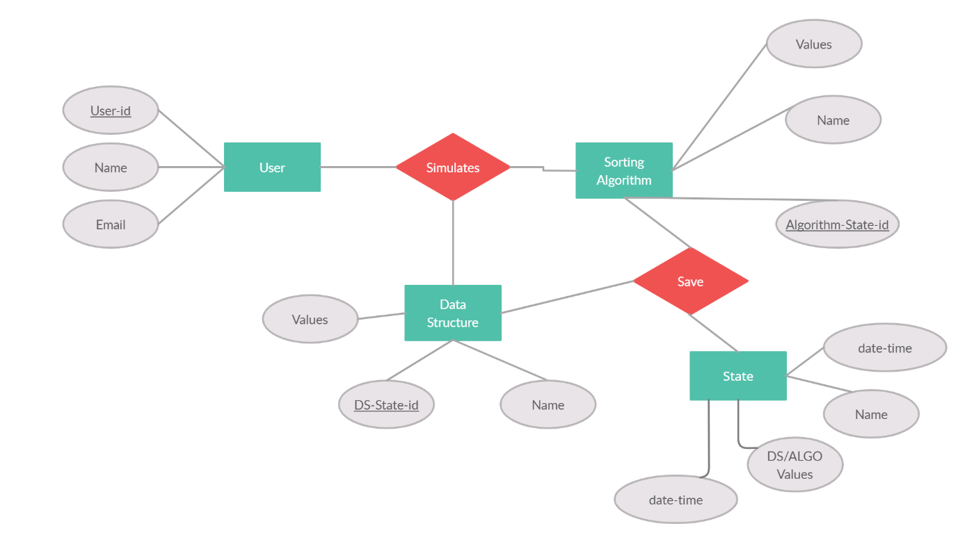**Class diagram:**

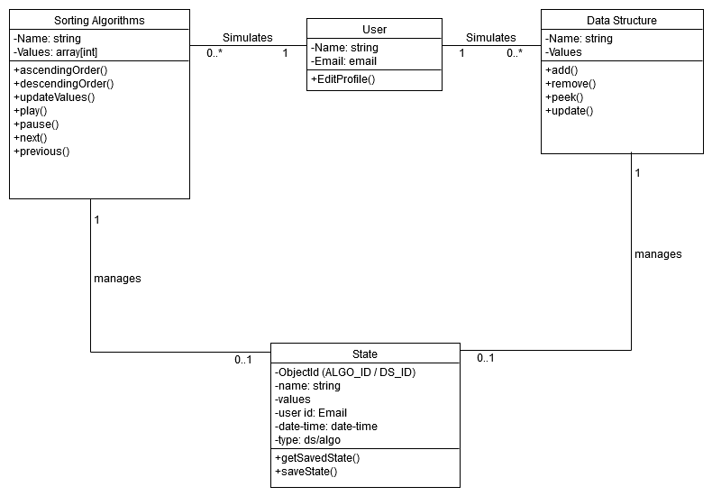

**Data Dictionary:**

**User:**

|  |  |  |  |  |  |  |
| --- | --- | --- | --- | --- | --- | --- |
| **No** | **Field Name** | **Data Type** | **Required** | **Unique** | **PK/FK** | **Description** |
| 1 | id | number | yes | yes | PK | Auto Increment |
| 2 | Name | string | yes | no |  |  |
| 3 | Email | email | yes | yes |  |  |

**Data Structure:**

|  |  |  |  |  |  |  |
| --- | --- | --- | --- | --- | --- | --- |
| **No** | **Field Name** | **Data Type** | **Required** | **Unique** | **PK/FK** | **Description** |
| 1 | id | number | yes | yes | PK | Auto Increment |
| 2 | Name | string | yes | no |  |  |
| 3 | Values | object | no | no |  |  |

**Sorting Algorithms:**

|  |  |  |  |  |  |  |
| --- | --- | --- | --- | --- | --- | --- |
| **No** | **Field Name** | **Data Type** | **Required** | **Unique** | **PK/FK** | **Description** |
| 1 | id | number | yes | yes | PK | Auto Increment |
| 2 | Name | string | yes | no |  |  |
| 3 | Values | object | no | no |  |  |

**State:**

|  |  |  |  |  |  |  |
| --- | --- | --- | --- | --- | --- | --- |
| **No** | **Field Name** | **Data Type** | **Required** | **Unique** | **PK/FK** | **Description** |
| 1 | id | number | yes | yes | PK | Auto Increment |
| 2 | Name | string | yes | no |  |  |
| 3 | Values | object | no | no |  |  |
| 4 | Object Id | number | yes | yes | FK |  |
| 5 | Date-Time | Date-time | yes | no |  |  |
| 6 | State-Type | string | yes | no |  |  |
| 7 | User id | number | yes | no | FK |  |